Year Level:  Teacher: | Unit Name: |  | Unit Timeframe:
Achievement Standard: (highlight aspects assessed in the unit)

Learning Intention: |  | Success Criteria:
Summative Assessment: |  | Formative Assessment:
Lesson Planning Considerations
High Impact Teaching Strategies:  Strategy 1: Setting Goals - Lessons have clear learning intentions with goals that clarify what success looks like.  Strategy 2: Structuring Lessons - A lesson structure maps the teaching and learning that occurs in class  Strategy 3: Explicit Teaching - When teachers adopt explicit teaching practices they clearly show students what to do and how to do it.  Strategy 4: Worked Examples - A worked example demonstrates the steps required to complete a task or solve a problem.  Strategy 5: Collaborative Learning - Collaborative learning occurs when students work in small groups and everyone participates in a learning task.  Strategy 6: Multiple Exposures - Multiple exposures provide students with multiple opportunities to encounter, engage with, and elaborate on new knowledge and skills.  Strategy 7: Questioning - Questioning is a powerful tool and effective teachers regularly use it for a range of purposes.  Strategy 8: Feedback - Feedback informs a student and/or the teacher about the student’s performance relative to the learning goals.  Strategy 9: Metacognitive Strategies - Metacognitive strategies teach students to think about their own thinking.  Strategy 10: Differentiated Teaching - Differentiated teaching methods are used to extend the knowledge and skills of every student in every class, regardless of their starting point. https://www.education.vic.gov.au/school/teachers/teachingresources/practice/improve/Pages/hits.aspx |  | Gradual Release of Responsibility Model* used:  For example:  - Establish Learning Intention and Success Criteria  - Collaborative Learning (We do) eg. Warm up/activate prior knowledge  - Demonstrating Instruction (I do – Teacher) eg. Demonstrating task using questioning  - Collaborative Learning (We do) eg. Think/Pair/Share, partner work, small groups  - Practising Learning (You do) + Coaching and Facilitating (additional support)  - Collaborative Learning (We do) eg. Work collaboratively on differentiated tasks  - Feedback – Review Learning Intention and Success Criteria with students  *Steps can be adjusted according to student needs  Fisher and Frey 2008
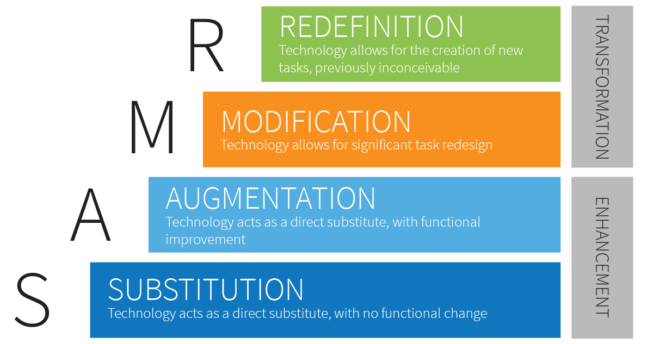  Incorporating ICTs:  The SAMR model is a simple way to evaluate how you incorporate technology within your classroom.  Utilise Apple native apps and other apps within the SAMR model (shown) to move from curriculum enhancement to curriculum transformation.  Apple native apps e.g. Pages, Keynote, iMovie, Garage Band, Notes,  Other apps e.g. Showbie, Book Creator, Stop Motion  SAMR example:  S – Substitution – Type notes within Pages app  A – Augmentation – Student chooses a preferred app to record note  M – Modification – Students collaborate with their writing on Showbie  R – Redefinition – Teacher accesses student work through Showbie |  | Age Appropriate Pedagogies Approaches used:  - Inquiry Learning – Beginning with a question, problem or idea, children plan and carry out investigations, propose explanations and solutions, and communicate their understandings in a variety of ways  - Event Based – Children plan and enact events in real-life contexts drawing on their ideas and experiences to connect knowledge and practice.  - Project Approach – An in-depth exploration of a topic with an emphasis on children creating a specific outcome (e.g. artefact, poster or presentation)  - Explicit Instruction – A structured and systemic approach to teaching academic skills guided by a stated purpose, explanation and demonstration, and supported by practice and feedback.  - Play Based Learning – Children actively and imaginatively engage with people, objects and the environment to enact ideas, create worlds, and re-create experiences, promoting holistic development and oral and narrative competencies.  - Direct teaching/instruction – A step-by-step lesson by lesson approach to teaching which is scripted and follows a pre-determined skill acquisition sequence.  - Blended Approach – Combines elements of more than one approach.
HOOK: (Spark to engage learners) |  | Link to real world/Purpose: (Learning makes connections to the real world)

LESSON SEQUENCE
Lesson Focus | Lesson Strategies | Planned Differentiation ie. ICPs, extension, identified needs |  | Resources
 |  | Student/s | Adjustment Strategy

